CTMS Integration Suite Project

Use Case Name: Enroll Subject

STORYBOARD:
CRA verifies that the patient meets eligibility criteria and if so, registers the patient (C3PR) to the study. Once they are registered/enrolled to a study, notification needs to go out to multiple systems (SC, CDMS). The message needs to indicate that the registration date needs to be the first date of the treatment epoch. CRA will review the SC and schedule the next visit and associated activities for that patient.

Assumptions:
- We are assuming that the Study is approved and open for accrual at this site, all applications have been informed (C3PR, C3D, etc.) to initiate the Study. This is the functionality of the future PLT application. C3D will begin the Study setup process and C3PR will get ready to enroll subjects. This use case starts with the assumption that both C3D and C3PR are aware of Study activation. C3D will carry minimal Study information and the rest will be added into C3PR.
- We are assuming that each Protocol/Study has a unique identifier and an unique short title
- We are assuming that the subject has signed the consent forms
- We are assuming that the screening has been done and the subjects eligibility information has been entered into C3PR (does C3PR have patients who are not eligible to a specific Study?)
- C3PR will assign the unique subject GRID identifiers and once a subject is enrolled to a study the exchange of data between applications will be based on Study id and subject id (GRID id).
- We are assuming that all the study events are triggered by the Registration Date. This date forms the baseline.
- At this point, C3PR does not refer to a specific release (Release 1 or Release 2)
- PSC and C3D will be able to harmonize and exchange some core study schedule/planning data/visit/activity data.

Implementation Notes from combined team call on 12/11/06:
- PSC will have to set up a Treatment epoch as the first epoch. The start date of this treatment epoch will be the Registration date provided by C3PR for that study. This will happen when the test study is being setup. No application level change in PSC!
- If the PSC does not have this subject, they will create this subject
- At present, we need a global subject identifier – may use grid identifiers for this purpose
- Assignment of GRID identifiers to subjects will need to happen at C3PR level. Needs further evaluation and discussion.
- C3PR does capture some data points that identify which subjects meet eligibility criteria (C3PR v1). Elig criteria Ind – Boolean value
- C3PR takes this elig criteria from caDSR
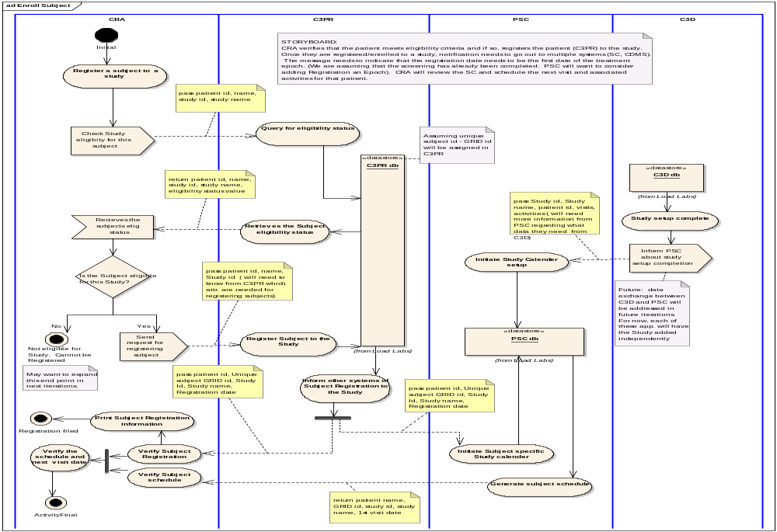

Open Questions for SMEs:
- How does the CRA know that a Study has been setup in C3D? Does the CRA need to query that in parallel to checking subject’s eligibility status?
- What are the various C3PR Eligibility statuses? Assuming a Yes/No for now based on input from C3PR team on combined call. Need to verify.
- Does C3PR assign subject to an arm during registration?
- Who decides which arm will be assigned to the subject? (PSC, C3PR, C3D??) – is this out of scope for this scenario?

Changes to AD

- Change Check Eligibility Status of the subject in the CRA swimlane for first sending signal
- Consider adding an activity that informs CRA about the completion of Registration. This information needs to presented in a printable format. The CRA needs to print and file this registration info.
- Add an activity before final – Print Registration
- Change Validate Subject Registration to Notify Subject Registration completion

